

OBJECT ORIENTED PROGRAMMING
LAB FILE
2025
Semester IV

Submitted By: Ayush Narula
Batch: 2 CCVT
Sap-Id: 500119444
ROLL NO: R-2142230440

LAB 1

1.Explore and understand the role of JDK, JRE, and JVM.
- JDK-: JDK stands for Java Development Kit, it is a software development kit used to write and compile Java programs. It includes tools like javac (compiler), java (runtime), and libraries for Java development.

- JRE-: JRE stands for Java Runtime Environment, it provides the libraries, Java virtual machine and other components to run Java applications. It is a subset of JDK.

- JVM-: JVM is Java Virtual Machine, it runs Java bytecode on your machine. It converts the bytecode (compiled java code) into machine code for execution. It ensures platform independence.

2.Install JDK and verify Java environment.

Visit the Oracle JDK website. Go to the macOS section and download the desired version of JDK.
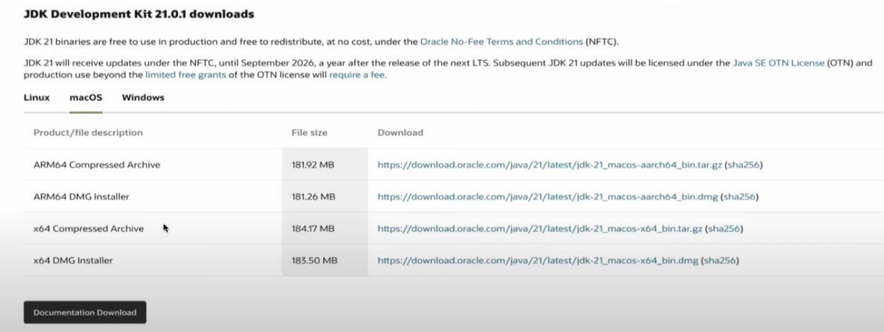
It will start downloading.
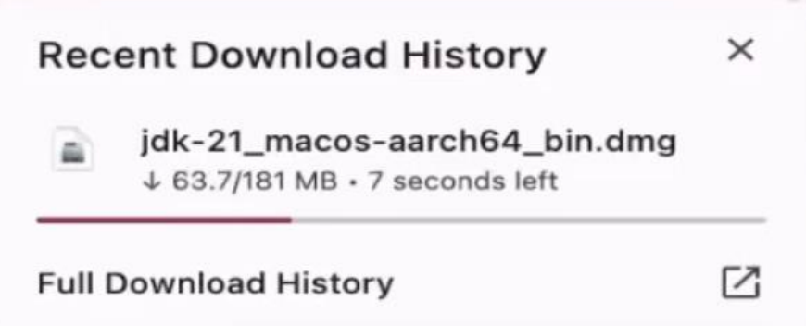
We need to follow all the next steps to download the JDK.
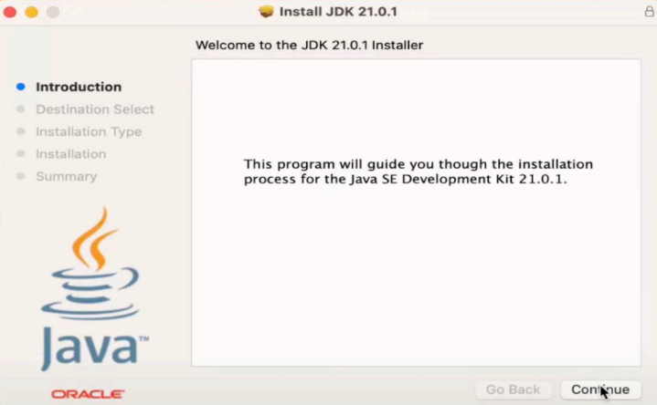
After the installation, open terminal and type this command to see that our JDK is successfully downloaded.
3. Create a simple hello word program and execute it.
CODE-:
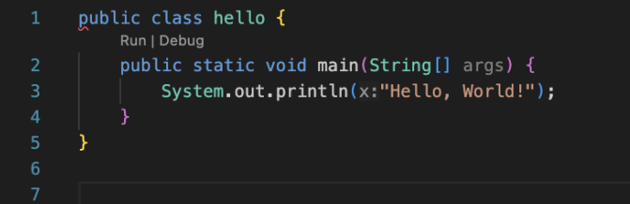
OUTPUT-:

4. Display your name and address in different line.
CODE-:
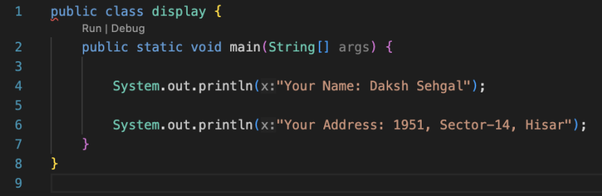
OUTPUT-:
